ITA0305- Mobile Computing
LAB EXPERIMENT
Name: G.Ganesh
Reg NO:192373008

20. Develop a troubleshooting flow for common issues in ad hoc networks.
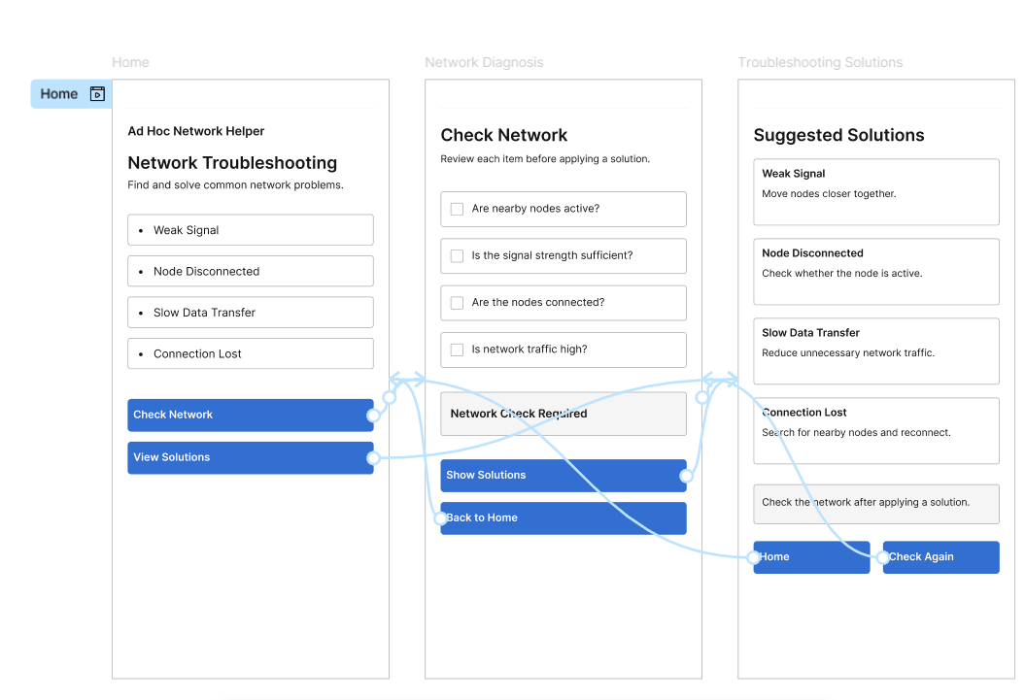
https://www.figma.com/design/ptL1gbbVldIh4M4sme7L2E/program20?node-id=0-1&p=f&t=xVNQHZDBE59ImOFn-0

